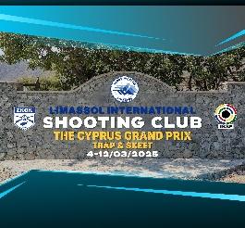

***ANNEX 04***

***THE CYPRUS GRAND PRIX***

***TRAP - SKEET***

***04 – 12 March 2025***

***Limassol International Shooting Range***

***Armenochori – Limassol - Cyprus***

***INDIVIDUAL ENTRY FORM***

***(One form for each participating athlete)***

|  |  |
| --- | --- |
| ***SURNAME*** |  |
| ***FIRST NAME*** |  |
| ***COUNTRY*** |  |
| ***MOBILE TEL.*** |  |
| ***FAX*** |  |
| ***E-mail*** |  |

***Participation is intended in the following event / category:***

|  |  |  |
| --- | --- | --- |
| ***EVENT*** | ***TRAP*** | ***SKEET*** |
| ***Please tick √*** |  |  |

|  |  |  |  |  |  |
| --- | --- | --- | --- | --- | --- |
| ***CATEGORY*** | ***MAN*** | ***MAN JUNIOR***  ***(-21)*** | ***VETERAN***  ***(50+)*** | ***WOMAN*** | ***WOMAN JUNIOR***  ***(-21)*** |
| ***Please tick √*** |  |  |  |  |  |

|  |  |
| --- | --- |
| ***Date*** | ***Signature*** |
|  |  |